**Project Overview**

We want to test a hypothesis from the perspective of behavioural finance, that the social media have a noticeable impact on individuals' decisions, thus, building a direct correlation between "public sentiment" and "market sentiment". Specifically, we hope to discover certain pattern between the stock price of Regal Entertainment Group (REG) and related Twitter discussion data of new movie releases. REG operates the largest movie theatre chain in USA. We assume that the more people discuss recent new movies on Twitter, the more they will go to cinemas to watch, hence, the investors hope they will bring more revenues to REG.

**Selection of Movies**

We only choose the national wide released movies as there are many movies or dramas released at limited places in US every month.

**Target Movies in April 2015**

|  |  |  |
| --- | --- | --- |
| **Movie** | **Release Date (all on Friday)** | **BO Revenue USD (M)** |
| Furious 7 | April 3 | 1.516B |
| The longest ride | April 10 | 62.94 |
| Paul Blart: Mall Cop 2 | April 17 | 107.6 |
| The age of adaline | April 24 | 57.7 |

from http://www.movieinsider.com/movies/april/2015

The above four movies covered April nicely, and hence we want to study the relationship between movie tweets discussion or sentiment and the company stock performance for 7 days period for each movie release.

**Define Movie Keyword to Scan Tweets**

For each movie, we choose to use the movie title, official movie account in Twitter, and some hash tag if any to scan all the relevant data. If the hash tag content is the same as account name, then we combine the two, e.g. [@TheLongestRide](https://twitter.com/TheLongestRide), and #thelongestride will be replaced by just "thelongestride".

|  |  |
| --- | --- |
| **Movie** | **Keyword** |
| Furious 7 | Furious 7, FastFurious, furious7 |
| The longest ride | The longest ride, thelongestride |
| Paul Blart: Mall Cop 2 | Paul Blart: Mall Cop 2, paulblartmovie, blartridesagain |
| The age of adaline | The age of adaline, ageofadaline |

**Regal Entertainment Group Stock Price**

The historical stock price of Regal Entertainment Group (NYSE: RGC) are retrieved from Yahoo! finance.

|  |  |  |  |  |  |
| --- | --- | --- | --- | --- | --- |
| Date | Open | High | Low | Close | Volume |
| 1 May 2015 | 22.03 | 22.60 | 21.88 | 22.13 | 1,512,500 |
| 30 Apr 2015 | 22.25 | 22.46 | 21.90 | 22.00 | 1,584,600 |
| 29 Apr 2015 | 22.23 | 22.49 | 22.09 | 22.33 | 888,000 |
| 28 Apr 2015 | 22.27 | 22.41 | 22.07 | 22.29 | 672,700 |
| 27 Apr 2015 | 22.69 | 22.72 | 22.31 | 22.33 | 450,000 |
| 24 Apr 2015 | 22.37 | 22.73 | 22.24 | 22.59 | 797,400 |
| 23 Apr 2015 | 22.02 | 22.37 | 21.89 | 22.27 | 572,600 |
| 22 Apr 2015 | 22.09 | 22.16 | 21.77 | 22.00 | 651,900 |
| 21 Apr 2015 | 22.37 | 22.43 | 22.03 | 22.12 | 1,136,600 |
| 20 Apr 2015 | 22.25 | 22.48 | 22.22 | 22.29 | 547,500 |
| 17 Apr 2015 | 22.36 | 22.37 | 22.04 | 22.19 | 914,900 |
| 16 Apr 2015 | 22.22 | 22.43 | 22.11 | 22.37 | 517,800 |
| 15 Apr 2015 | 22.40 | 22.52 | 22.24 | 22.25 | 494,500 |
| 14 Apr 2015 | 22.32 | 22.48 | 22.12 | 22.34 | 703,600 |
| 13 Apr 2015 | 22.32 | 22.59 | 22.18 | 22.32 | 931,600 |
| 10 Apr 2015 | 22.79 | 23.11 | 22.78 | 22.79 | 395,600 |
| 9 Apr 2015 | 22.85 | 22.95 | 22.47 | 22.79 | 783,800 |
| 8 Apr 2015 | 22.72 | 23.04 | 22.55 | 22.96 | 993,400 |
| 7 Apr 2015 | 23.55 | 23.56 | 23.17 | 23.23 | 791,000 |
| 6 Apr 2015 | 23.29 | 23.67 | 23.10 | 23.60 | 1,379,100 |
| 2 Apr 2015 | 22.89 | 23.36 | 22.80 | 23.26 | 713,000 |
| 1 Apr 2015 | 22.80 | 22.92 | 22.36 | 22.87 | 996,100 |

from http://finance.yahoo.com/q/hp?s=RGC+Historical+Prices

**Process to Retrieve Tweets for Analysis**

We first clean up the whole April tweets data from the online archive by removing those unnecessary attributes, and limited the data size to about eight times lesser, 21.8GB.

text clean -> filter -> load

**Analysis**

2. We use Spark code to filter tweets data for each movie, and load them to MongoDB.

3. We use JS scripts to get each movie tweets data for each date as follows:

**Target analysis date and Movie table:**

|  |  |
| --- | --- |
| Movie | Analysis period |
| Furious 7 | April 1 - 7 |
| The longest ride | April 8 - 14 |
| Paul Blart: Mall Cop 2 | April 15 -21 |
| The age of adaline | April 22 - 28 |

**5. Initial Result**

|  |  |  |  |
| --- | --- | --- | --- |
| **Furious 7** | Stock price | Tweets Count | Timestamp_ms UTC + 0 |
|  |  |  |  |
| April 1 | 22.87 | 773 | 1427846400000 |
| 2 | 23.26 | 1498 | 1427932800000 |
| 3 | Close | 3106 | 1428019200000 |
| 4 | Close | 3021 | 1428105600000 |
| 5 | close | 3058 | 1428192000000 |
| 6 | 23.6 | 3274 | 1428278400000 |
| 7 | 23.23 | 1753 | 1428364800000 |
|  |  |  |  |
| **The longest ride, thelongestride** |  |  |  |
| 8 | 22.96 | 200 | 1428451200000 |
| 9 | 22.79 | 170 | 1428537600000 |
| 10 | 22.79 | 268 | 1428624000000 |
| 11 | Close | 399 | 1428710400000 |
| 12 | Close | 285 | 1428796800000 |
| 13 | 22.32 | 161 | 1428883200000 |
| 14 | 22.34 | 92 | 1428969600000 |
| "Paul Blart: Mall Cop 2","BlartRidesAgain" |  |  |  |
| 15 | 22.25 | 466 |  |
| 16 | 22.37 | 454 |  |
| 17 | 22.19 | 1056 |  |
| 18 | Close | 1273 |  |
| 19 | Close | 747 |  |
| 20 | 22.29 | 365 |  |
| 21 | 22.12 | 171 |  |

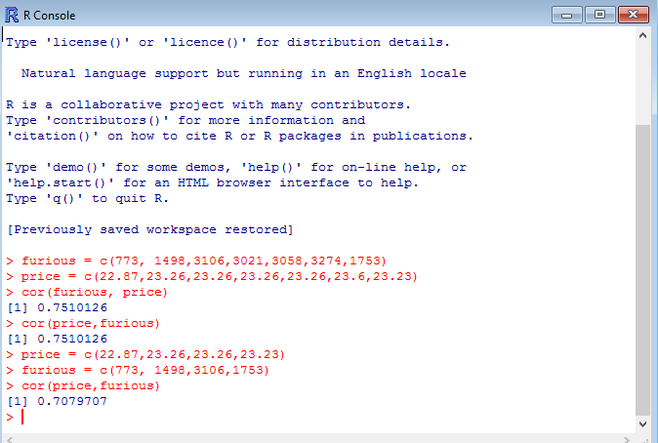

Our initial simple correlation calculation is that:

During the target period, the stock price of REG is correlated to the movie tweets as high as 0.71 for Furious 7, which is a very hot movie.

When the tweets amount reached highest on April 6, the stock price was highest in the period.

For longest ride, the correlation is 0.68.

For Paul Blart: Mall Cop 2 the correlation is -0.1, which means not correlated.

There were not cooperate events and stock split or dividend during this period.

However, we don't have much background in finance and statistic analysis, we want to know how to conduct in-depth analysis of our topic.

**Sentiment Analysis**

**NLTK Vader**

Not accurate 80% is negative although handle negation words.